**Module 7 Lab 1: Develop Secure Middleware & Backend Database for a Book Exchange Application**

**Submitted By: Praveen Kumar Siddela**

**IFT 458 & IFT 554: Middleware Programming & Database Security**

**Dinesh Sthapit**

**Due Date: 04/21/2024**

**Screenshot 1**: Of the terminal showing successful installation of dependencies.

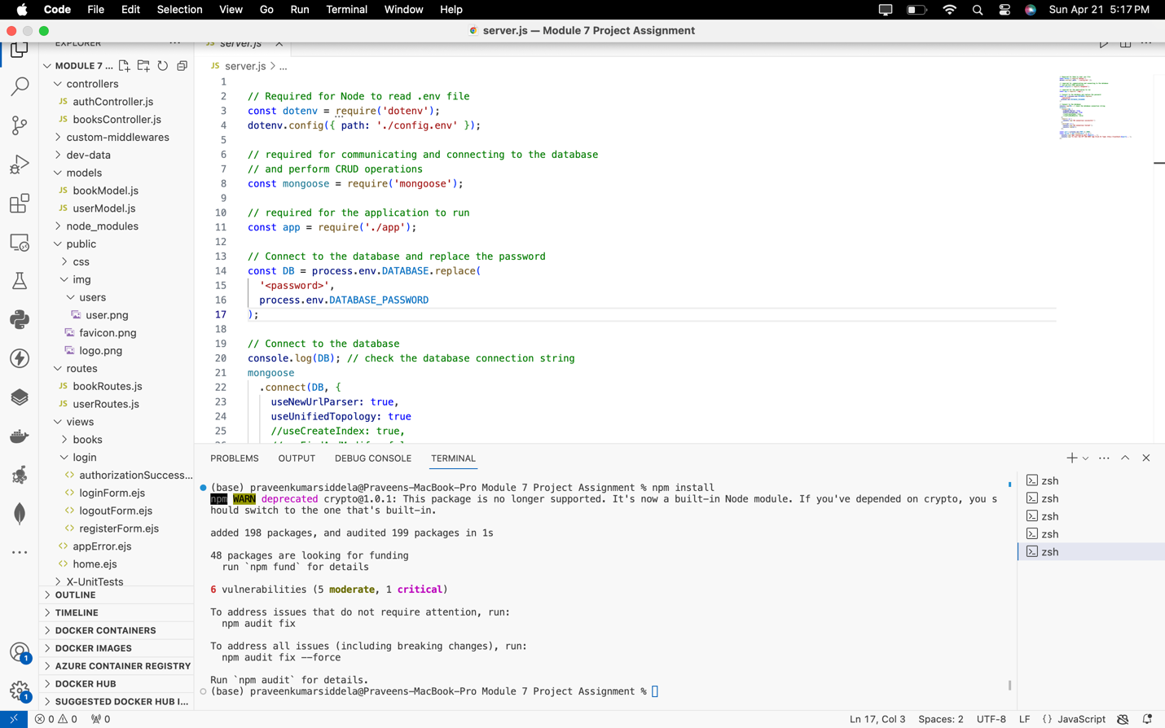

**Screenshot 2**: Of the project directory structure showcasing MVC organization.

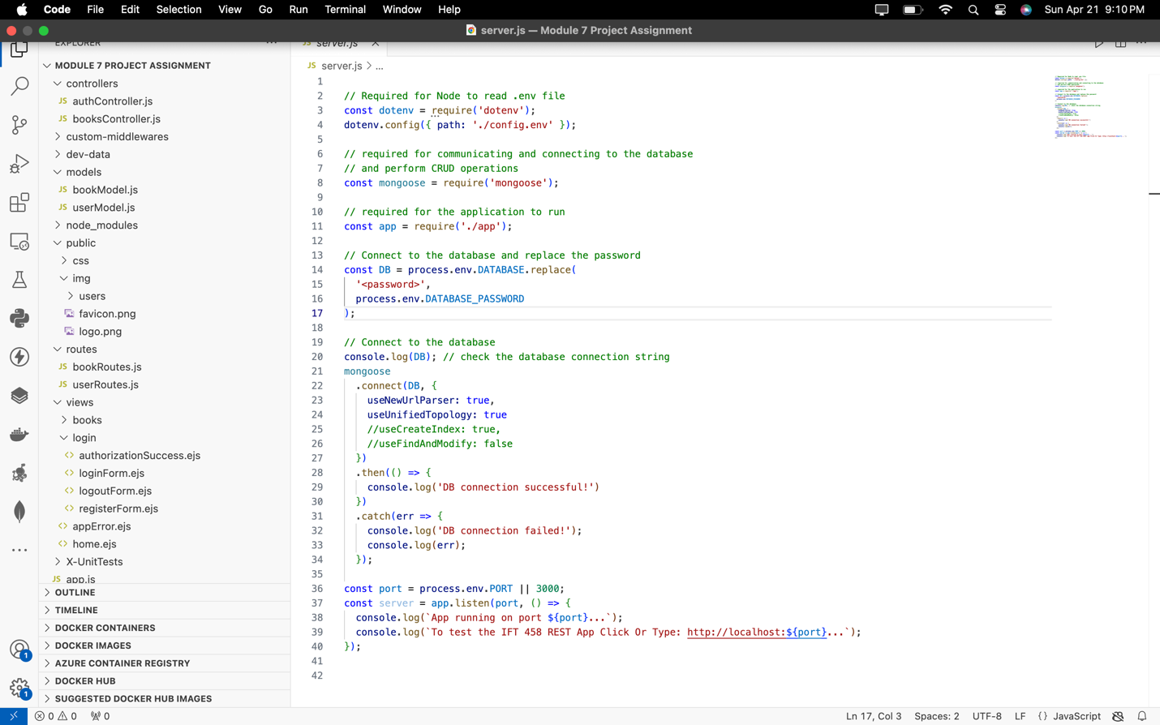

**Screenshot 3**: Of the BookModel.js file with a brief explanation.

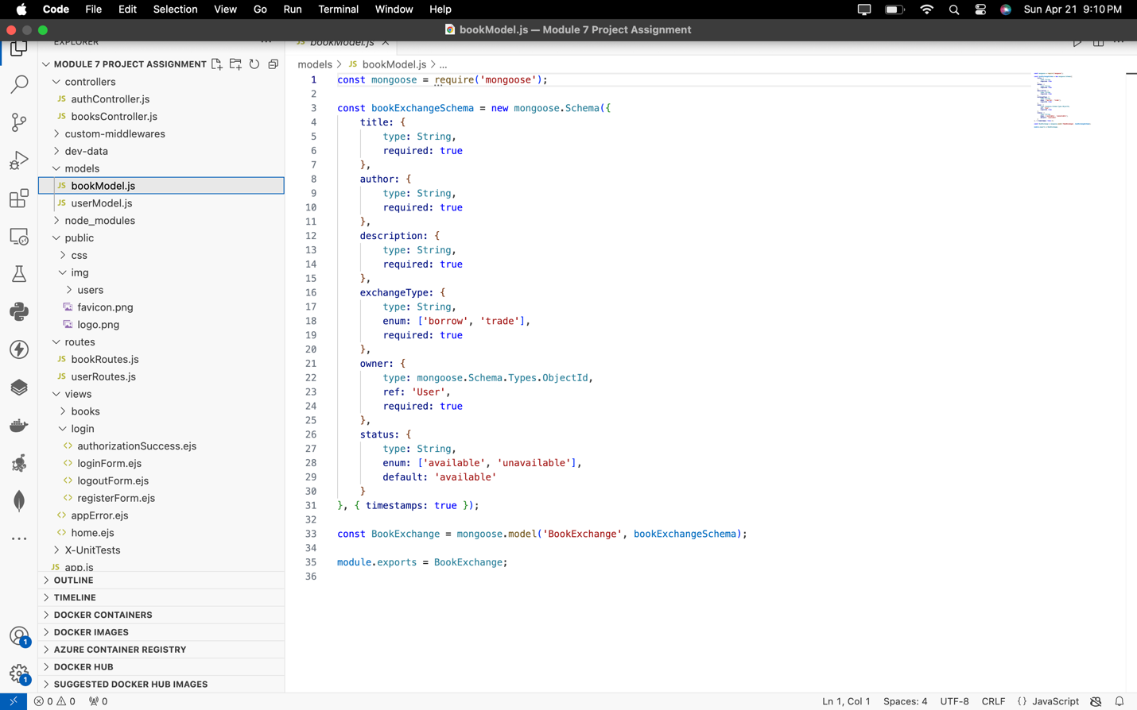

The **bookModel.js** file defines the book data structure for the application using Mongoose. It specifies properties like title, author, description, exchangeType, owner, and status, with precise data types and constraints. Enums ensure consistency for exchangeType and status. The owner field references the 'User' model. Default values and timestamps are included. The schema becomes a Mongoose model named 'BookExchange' for easy MongoDB interaction, exported for application-wide use.

**Screenshot 4**: Of the bookController.js with the implemented logic.

The **bookController.js** file handles book-related actions in the app. It includes functions for adding, retrieving, updating, and deleting books. Error handling ensures appropriate status codes and messages. Functions like addBook and updateBookForm handle user input, while createBook, getBooks, getBookById, updateBookById, and deleteBook interact with the database. Status codes like 400, 404, and 500 are used for various scenarios, ensuring smooth operation of book-related functionalities.

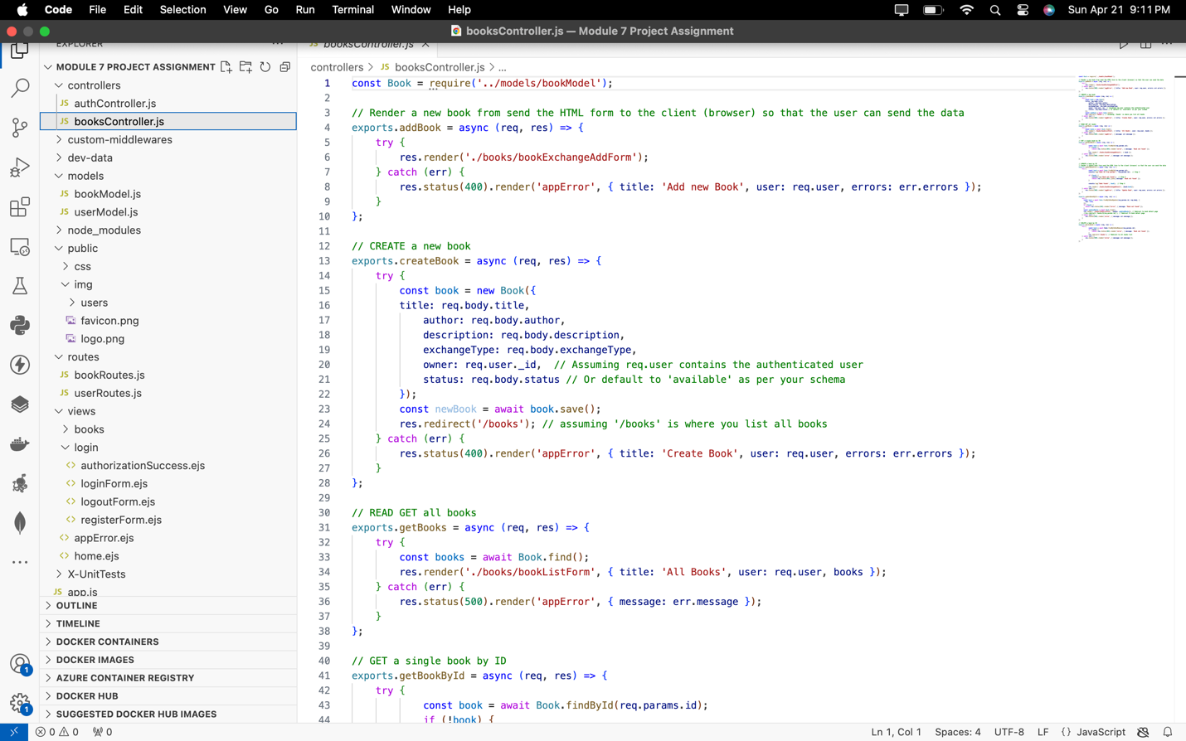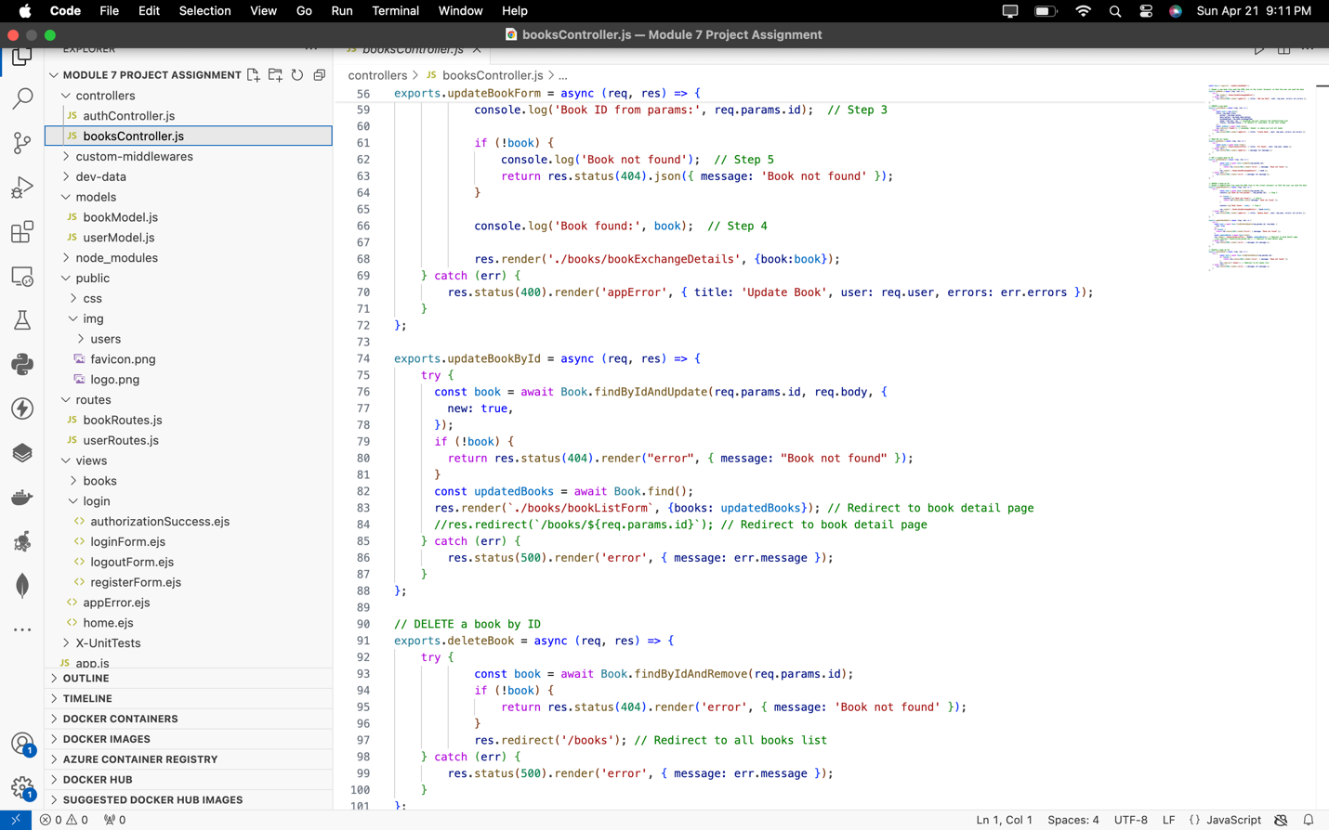

**Screenshot 5**: Of the bookRoutes.js file with defined routes.

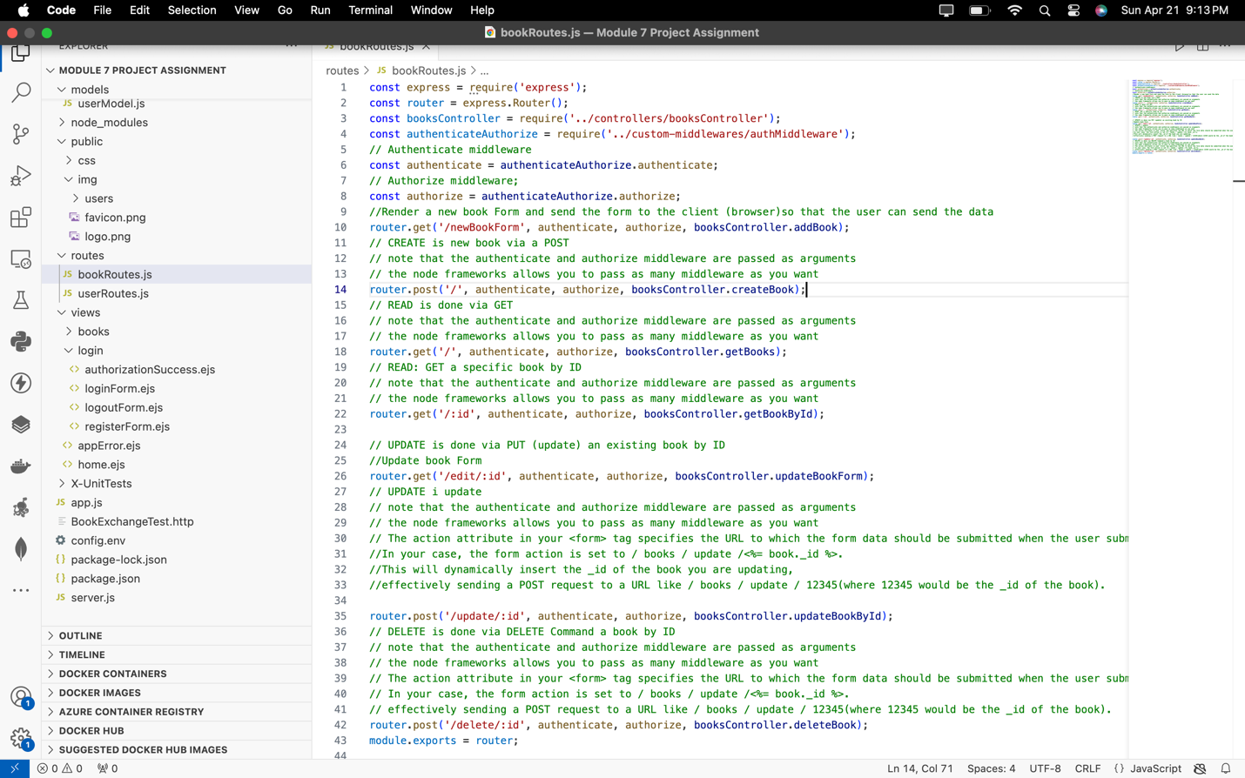

**Screenshot 6**: Of updated view files (*.ejs) and changes made.

The **bookExchangeForm.ejs** page is a web form for adding new books to a book exchange platform. It contains standard HTML structure with metadata and external resources like Bootstrap CSS and JavaScript files. The body section dynamically displays date, time, and user IP. When logged in, it shows a welcome message and links to dashboard and logout; otherwise, it provides signup/login buttons. The main section houses a form for entering book details and submitting them to **/books/add**. The footer includes copyright information. Overall, it serves as a user-friendly interface for adding books to the platform.

Top of Form

Bottom of Form

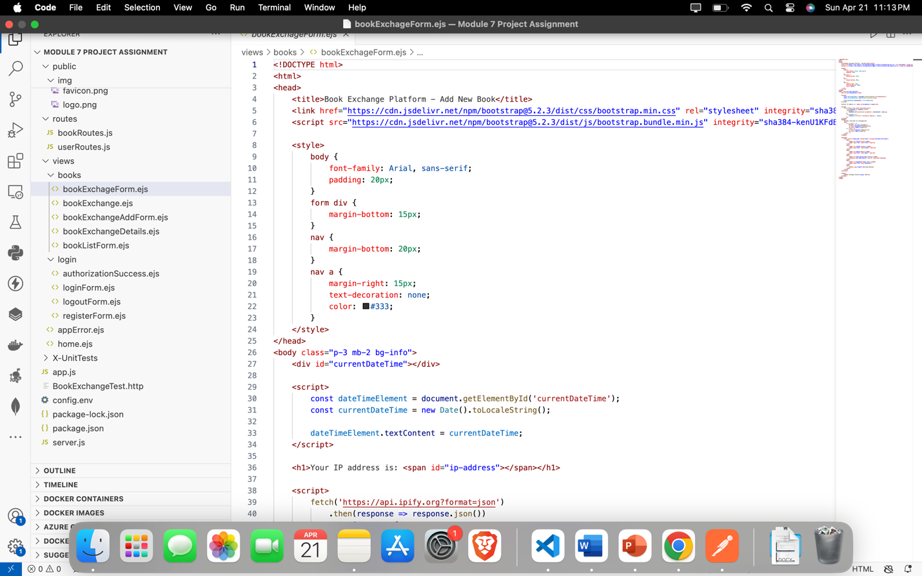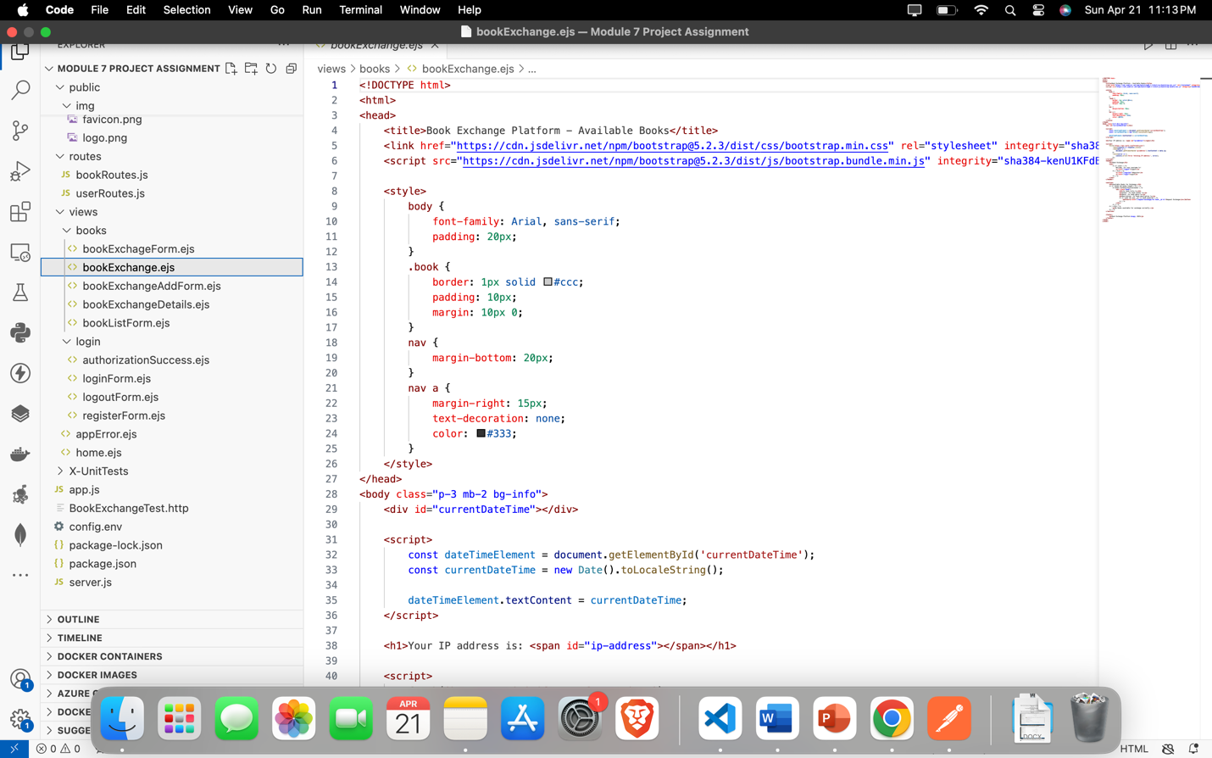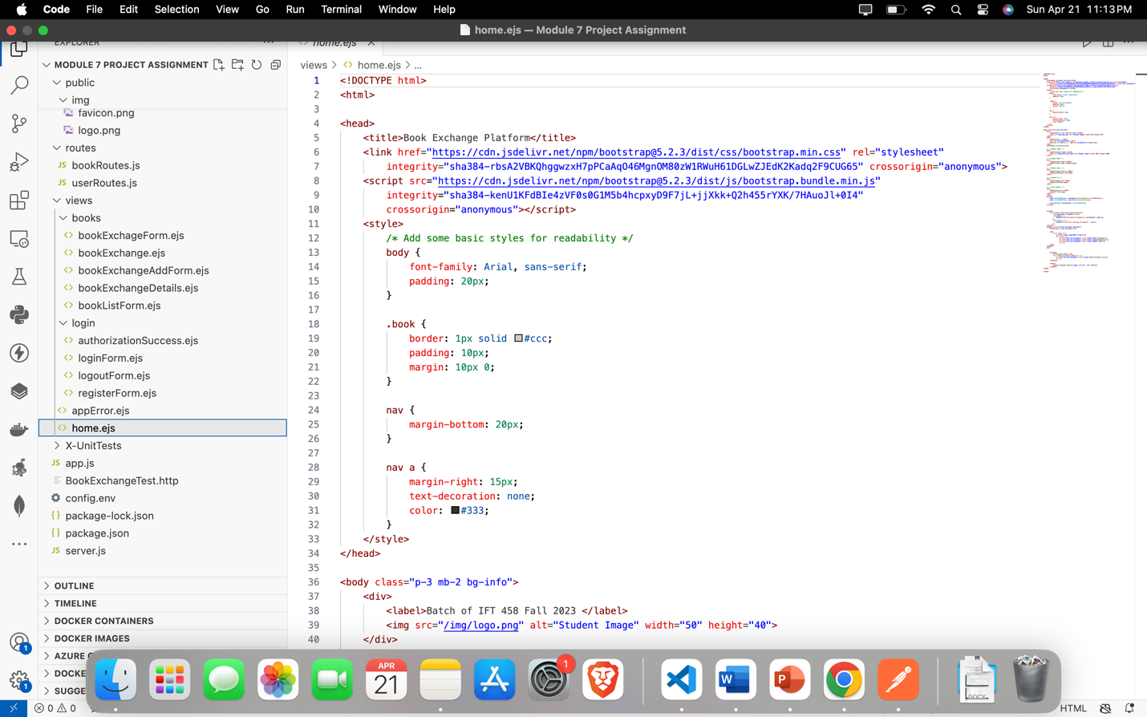

**Screenshot 7**: Of the home page as displayed in the browser.

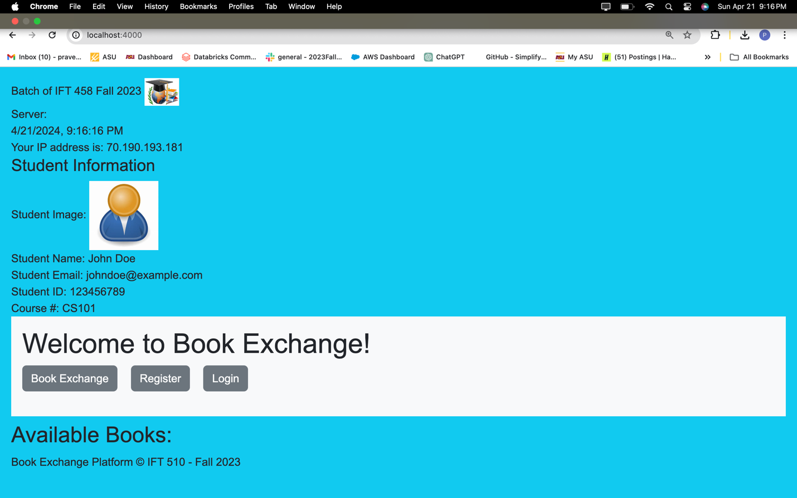

**Screenshot 8**: Of all personalized user interface pages.

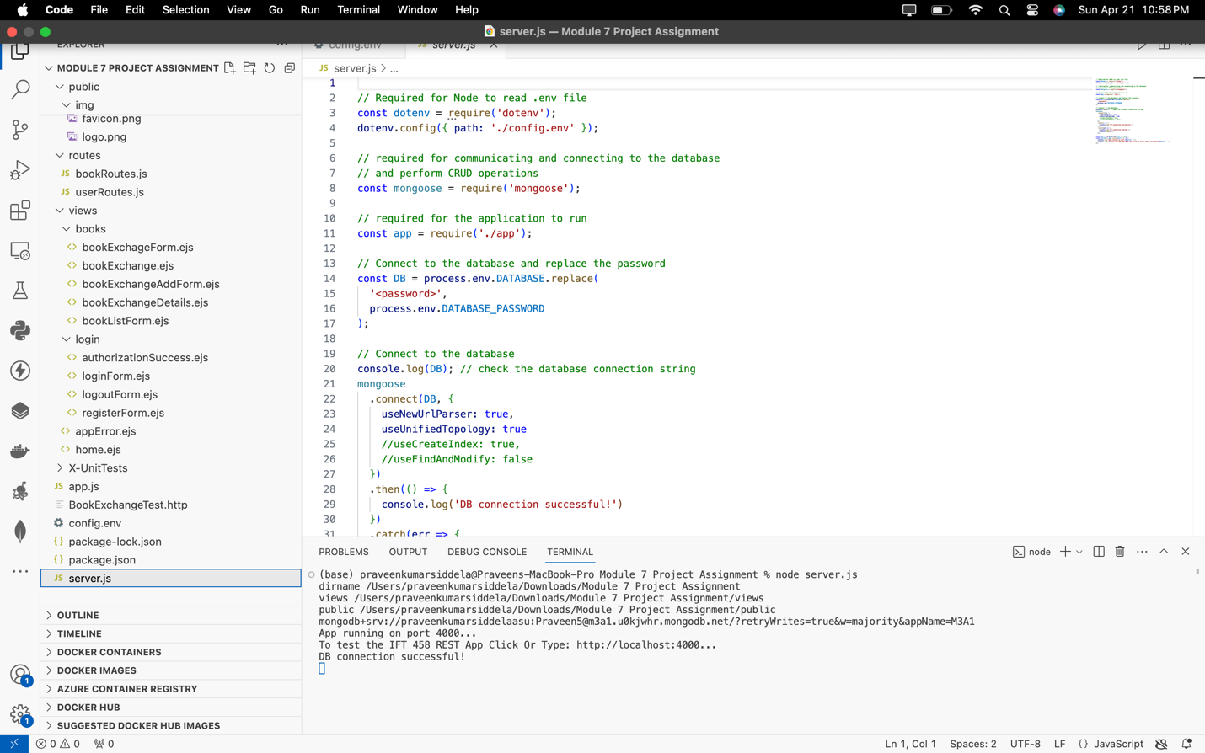

**Home Page:**

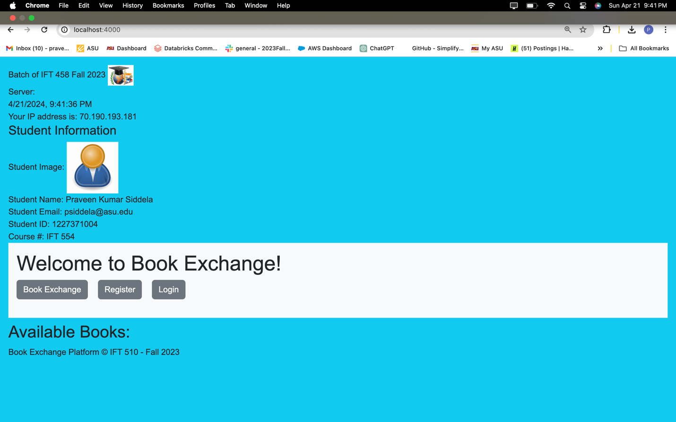

**Signup:**

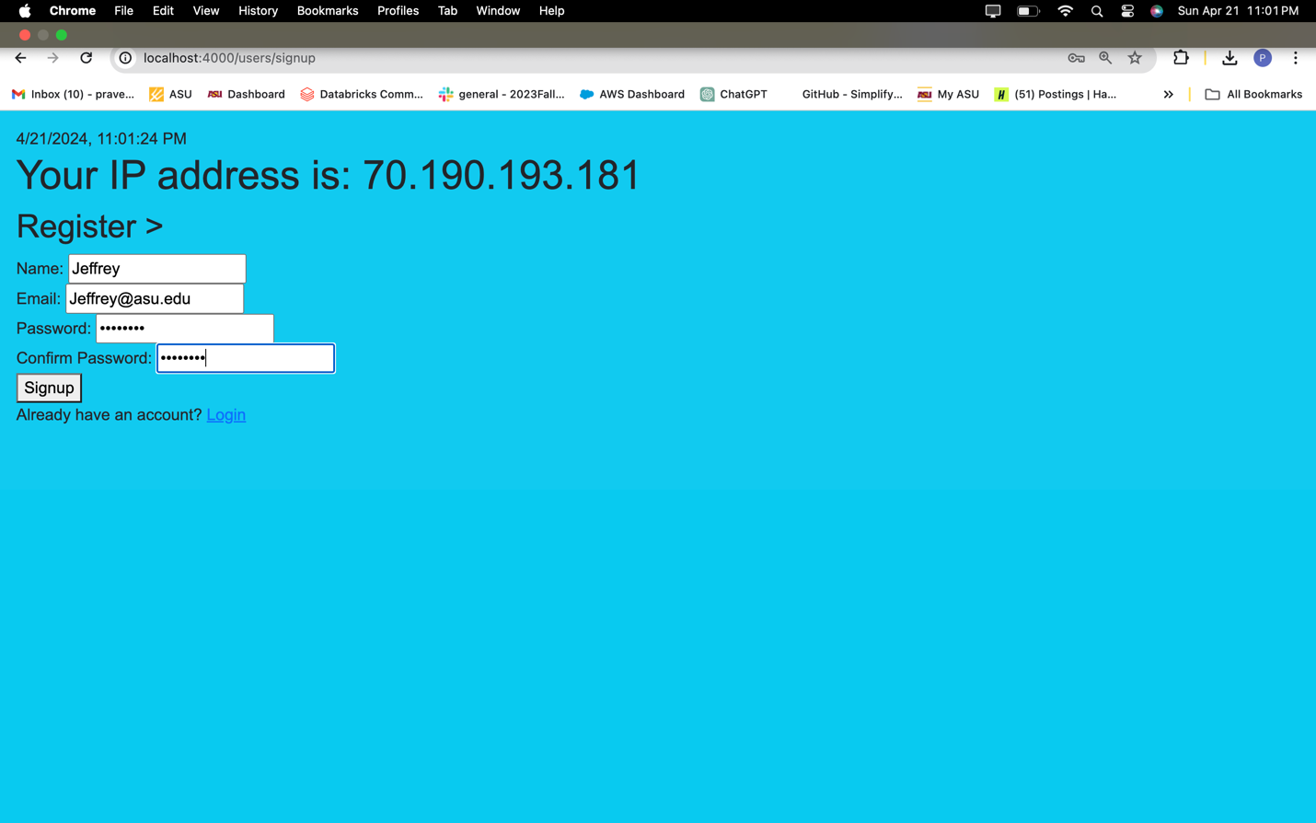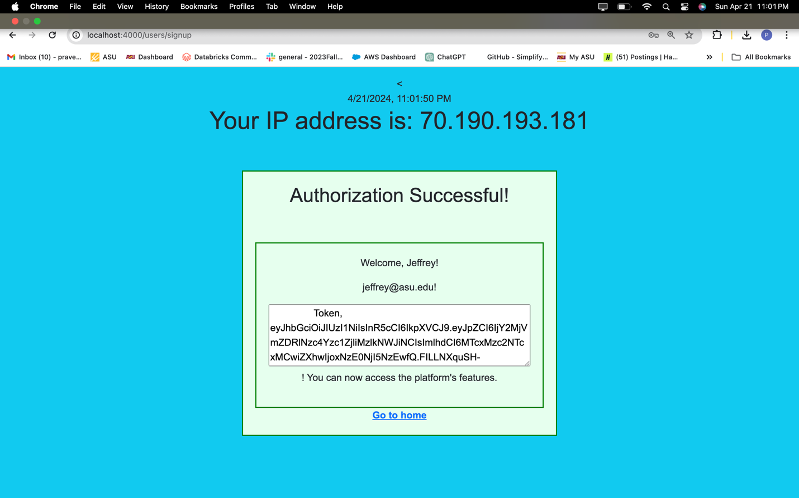

**Login Page:**

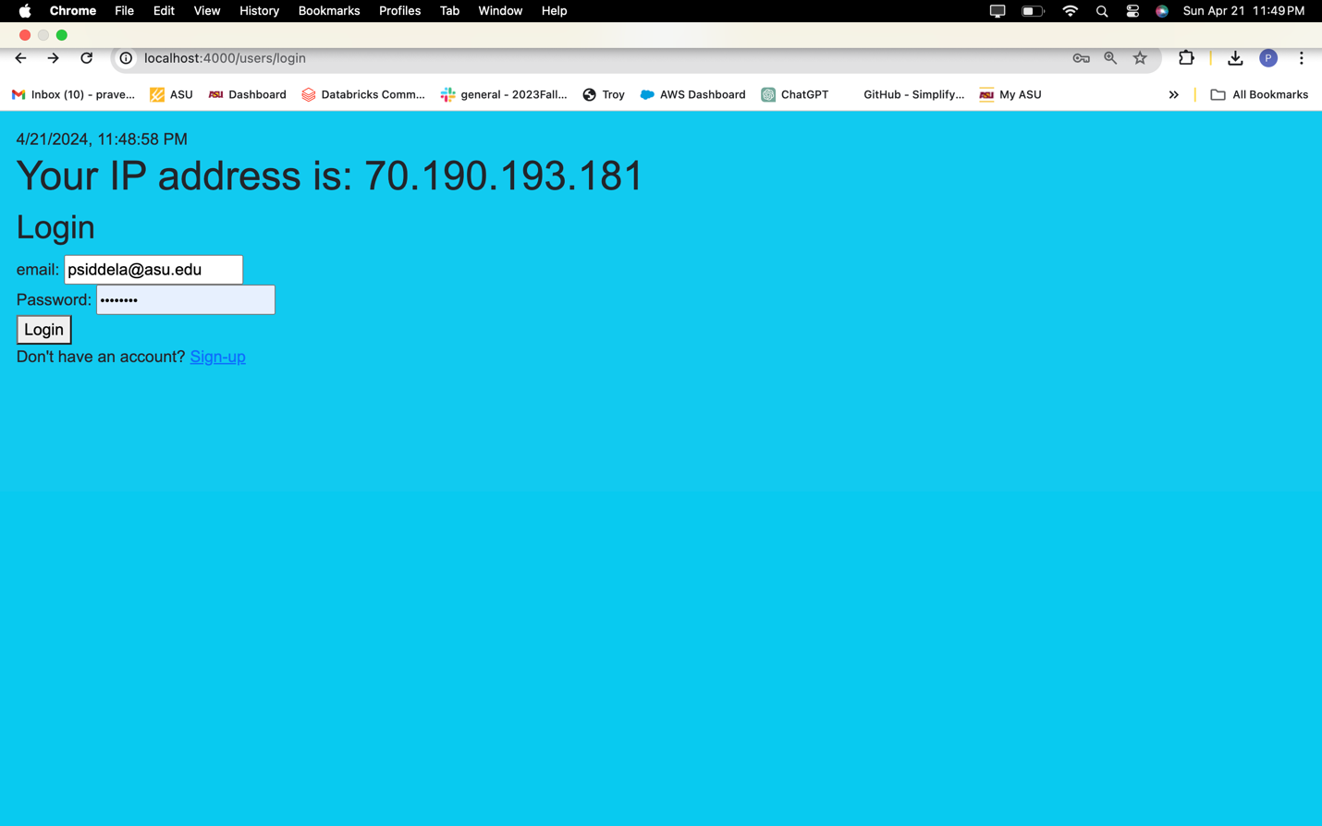

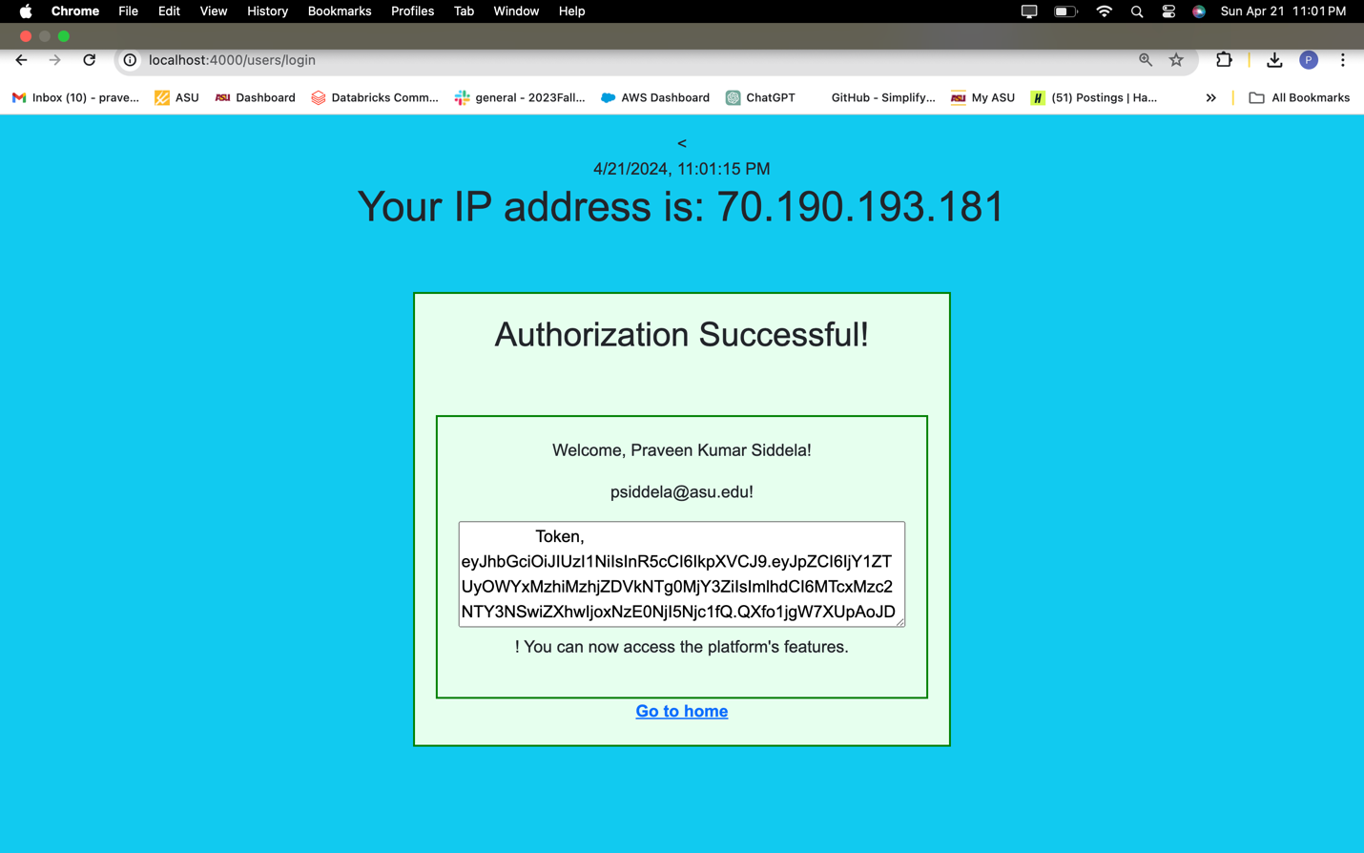

**Retrieve All Books:**

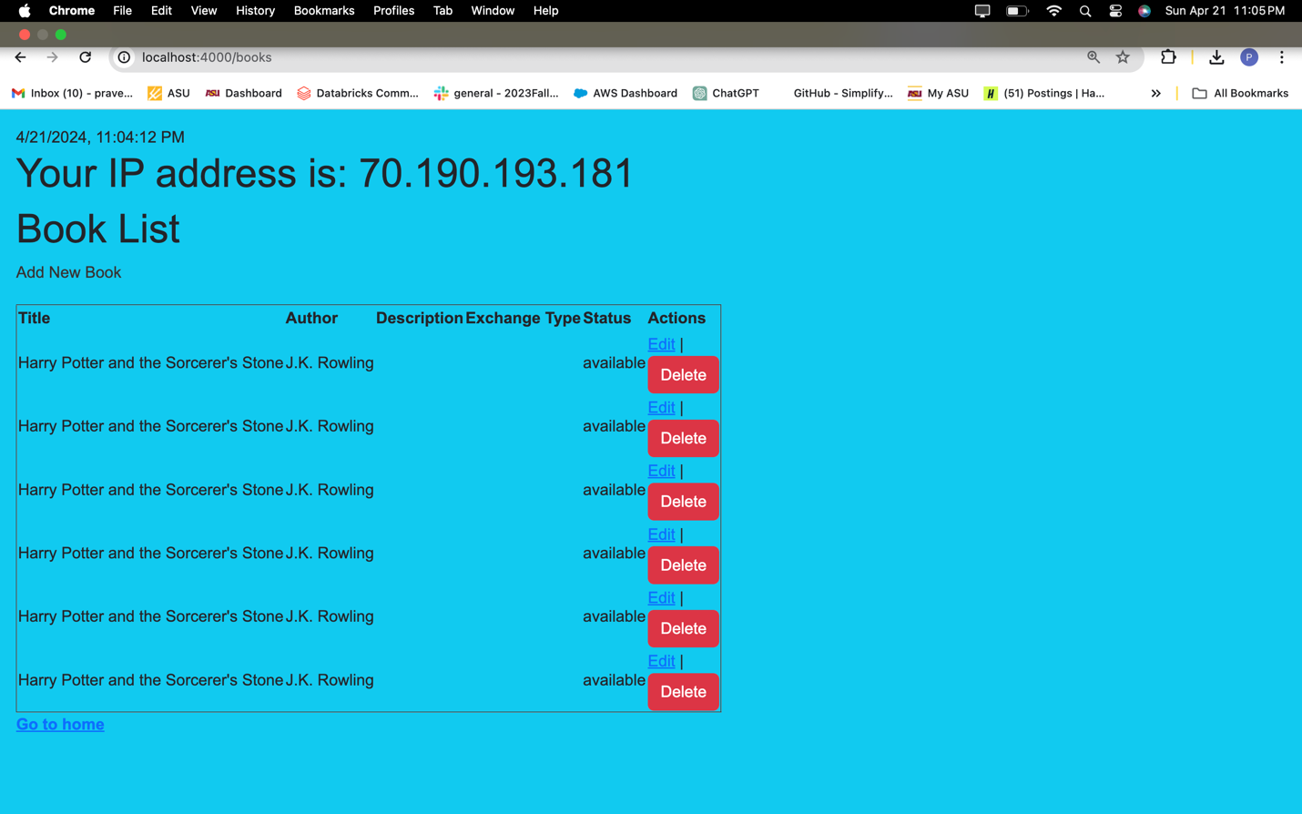

**Add New Book:**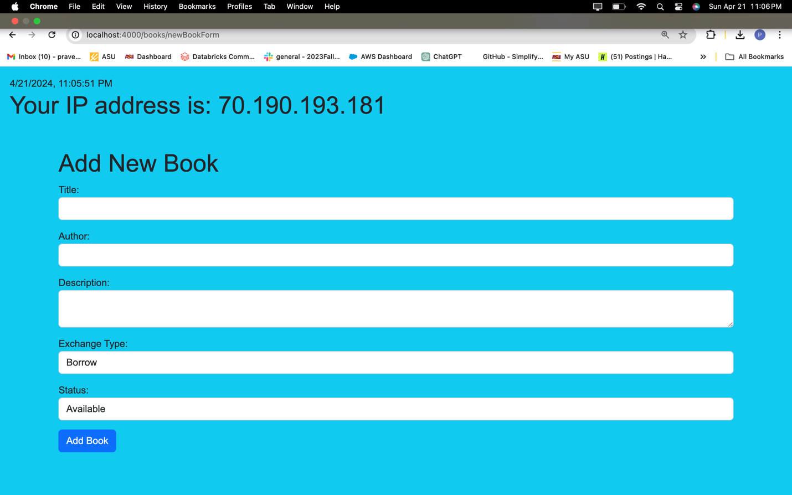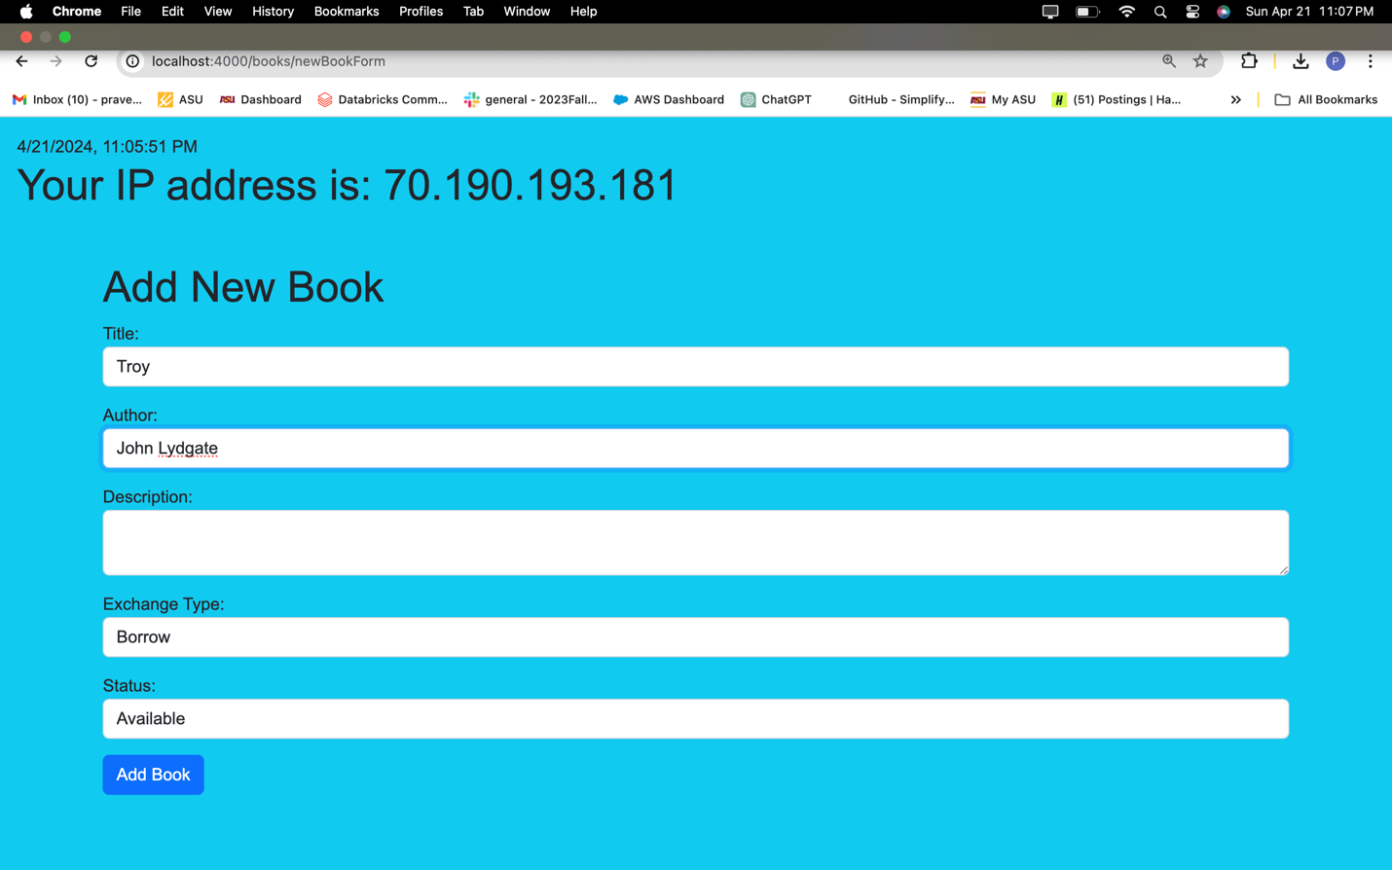

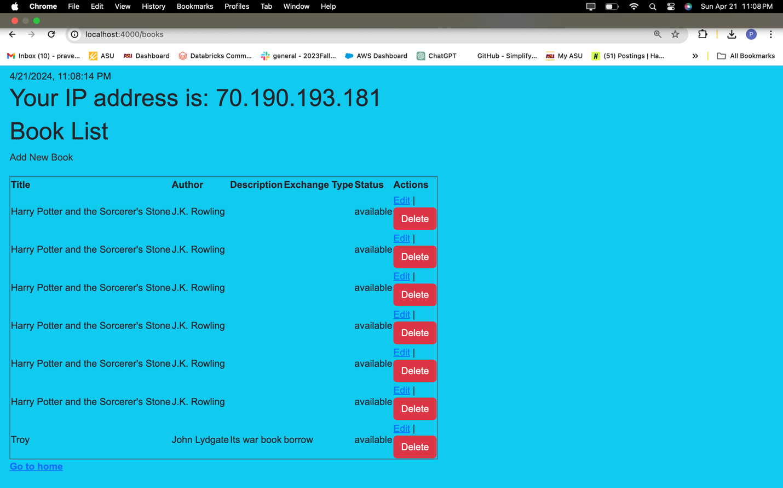

**Edit of the books:**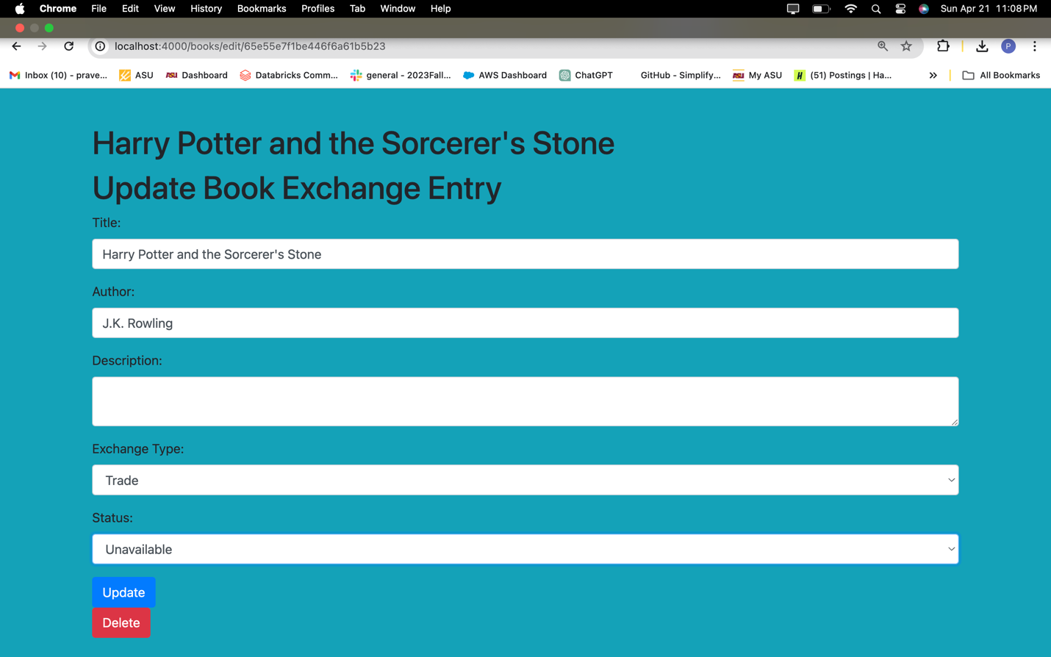

**Deletion of Books:**

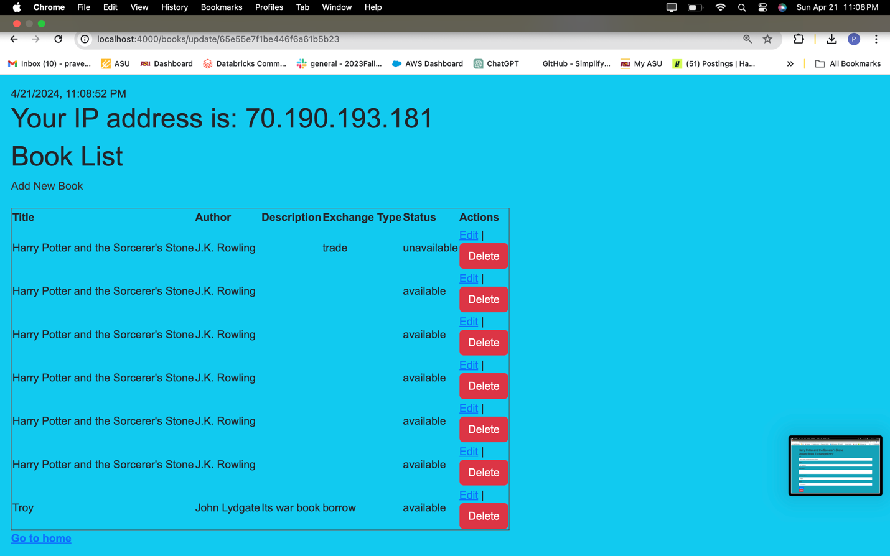

**After Deletion:**

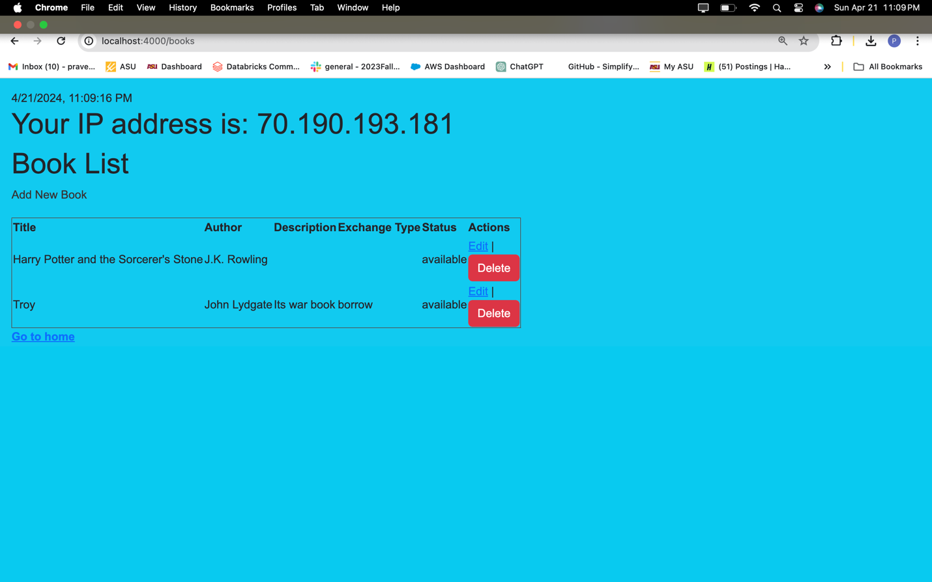

**Screenshot 9**: Of the testing process and responses for different API endpoints.

|  |  |  |
| --- | --- | --- |
| Feature | Method | URL End Point (the following are just the sample) You must update the URLs with the correct endpoints) |
| Register / Sign up | POST | <https://localhost:4000/users/signup> |
| Login | POST | <https://localhost:4000/users/login> |
| Protected Resource | GET | <https://localhost:4000/books> |
| View All Books | GET | <https://localhost:4000/books> |
| Add Book Exchange | POST | <https://localhost:4000/books/newBookForm> |
| Update Delete Exchange | POST | <http://localhost:4000/books/edit/65e565c188ab31ac49627500> |
|  |  |  |

**Screenshot 10**: Of API specification documentation and screenshots of the corresponding code for each endpoint.

**Post:Adding a New Book**

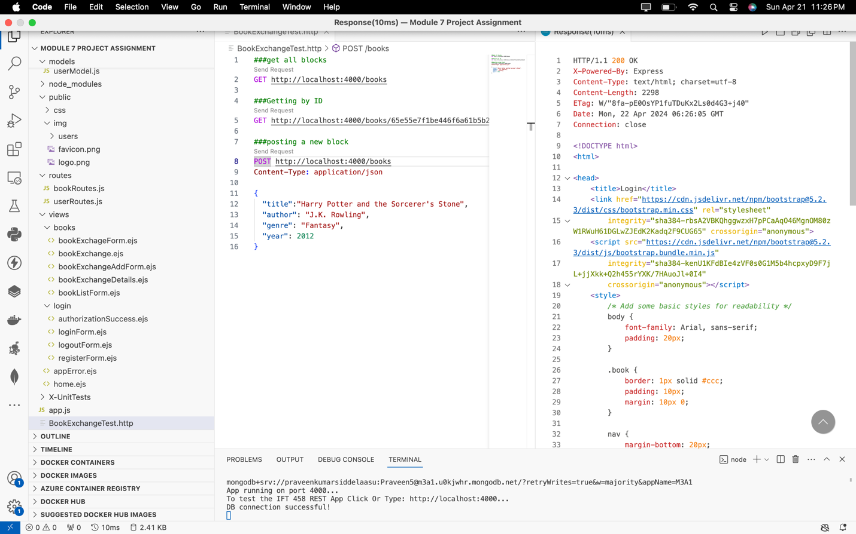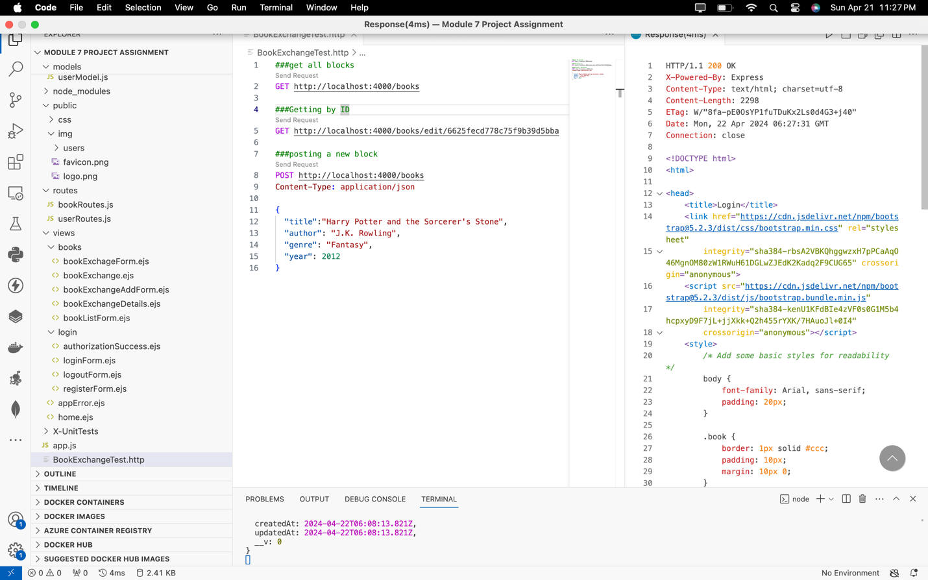



**Get Request:Retrieve all Books**

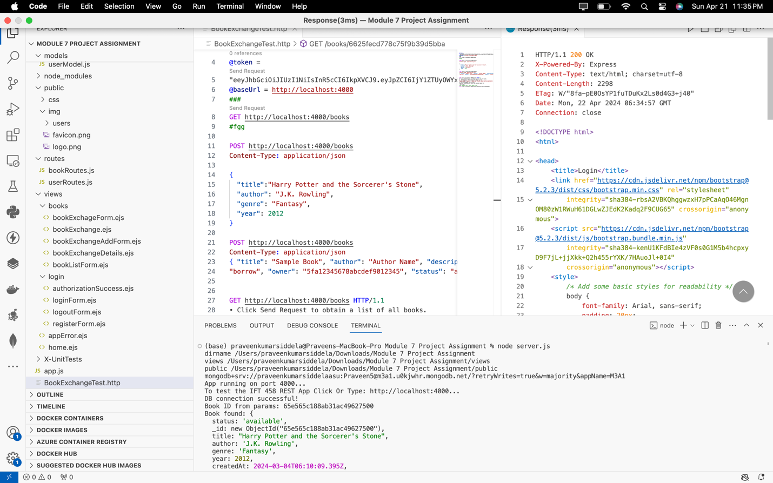



**GET Request: Fetch Specific Book by ID:**

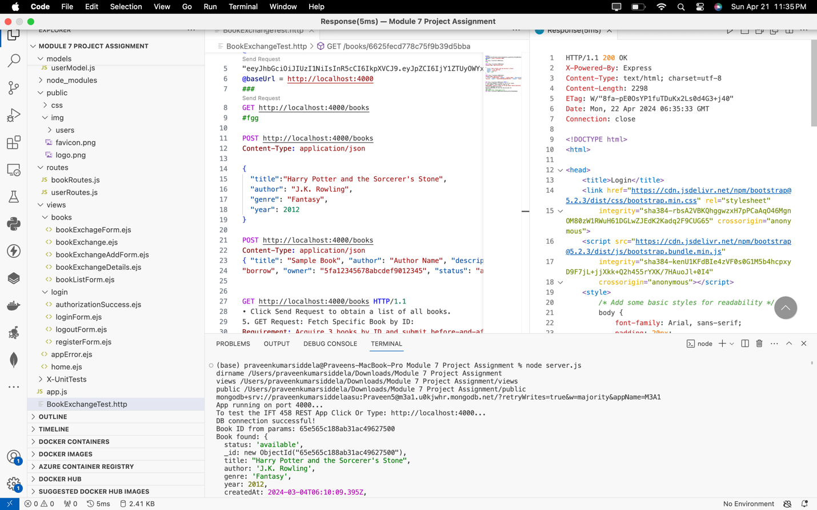

**PUT Request: Modify a Specific Book by ID:**

